B1
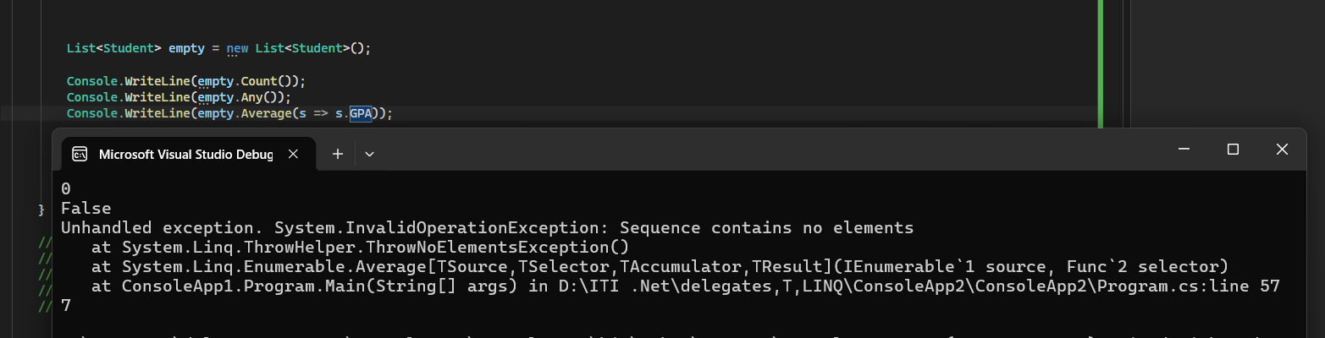

Predicted Output : 0 , False
, Unhandled exception: InvalidOperationException

Reason
- Count() returns 0 because the list is empty.
- Any() returns False because there are no elements.
- Average() cannot calculate the average of an empty collection, so it throws an InvalidOperationException.
B2
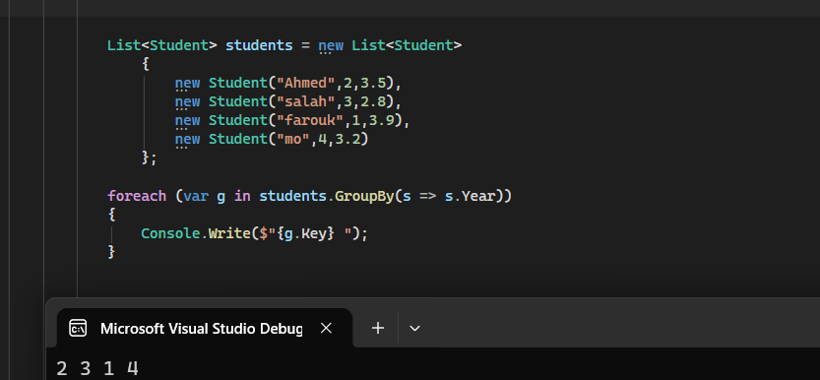
Predicted Output : 2 3 1 4

Reason : GroupBy() creates groups in the order the keys are first encountered in the source collection. It does not sort the groups automatically.

B3

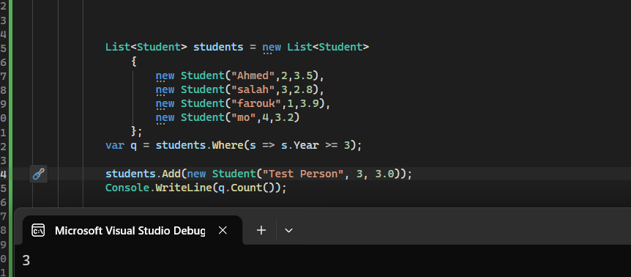

Predicted Output : 3

Reason : Where() uses deferred execution. The query is not executed when it is created, but when Count() is called. Since the new student is added before execution, the query includes the new student.

